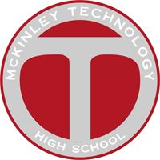
Mckinley tech
Class of 1979
Prayer Breakfast

NO ADMISSION FEE TO attend prayer breakfast

SATURDAY JUNE 20TH 9:30AM TO 11:30AM
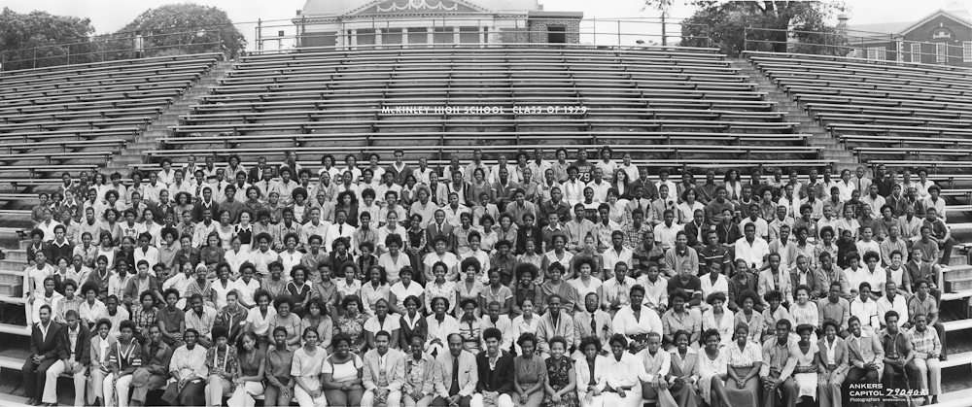

Holy Redeemer Catholic Church
206 New York Ave NW
Washington, DC

Located at the corner of New York & New Jersey Ave NW
Parking in the rear on Pierce St NW

RSVP @ www.mckinleytech1979.com

Registration Fees Will Be Accepted

Make Checks Payable to RAW Productions

Class reunion registration
We need everyone to register for the class reunion as soon as possible. We will accept registration fees in form of a check during the prayer breakfast event.

