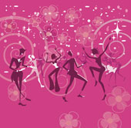



til the lights go out!
Pisces Birthday Celebration!
DENA,MIKE,RICO,GAIL
March 5, 2011
The Elks Lodge
7350 Temple Hills Road
Camp Springs
Maryland

Music By:
DJ Byrd!
Reserve a Table for
Your Birthday Celebration!
F r e e B u f f e t !
TICKETS
$15.00
For Ticket Information Contact:
Mike Rowe 202-731-3915

Time : 9:00 – 1:00
50 / 50
Raffle !

